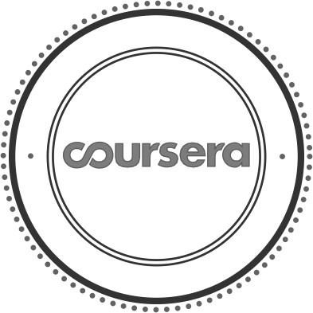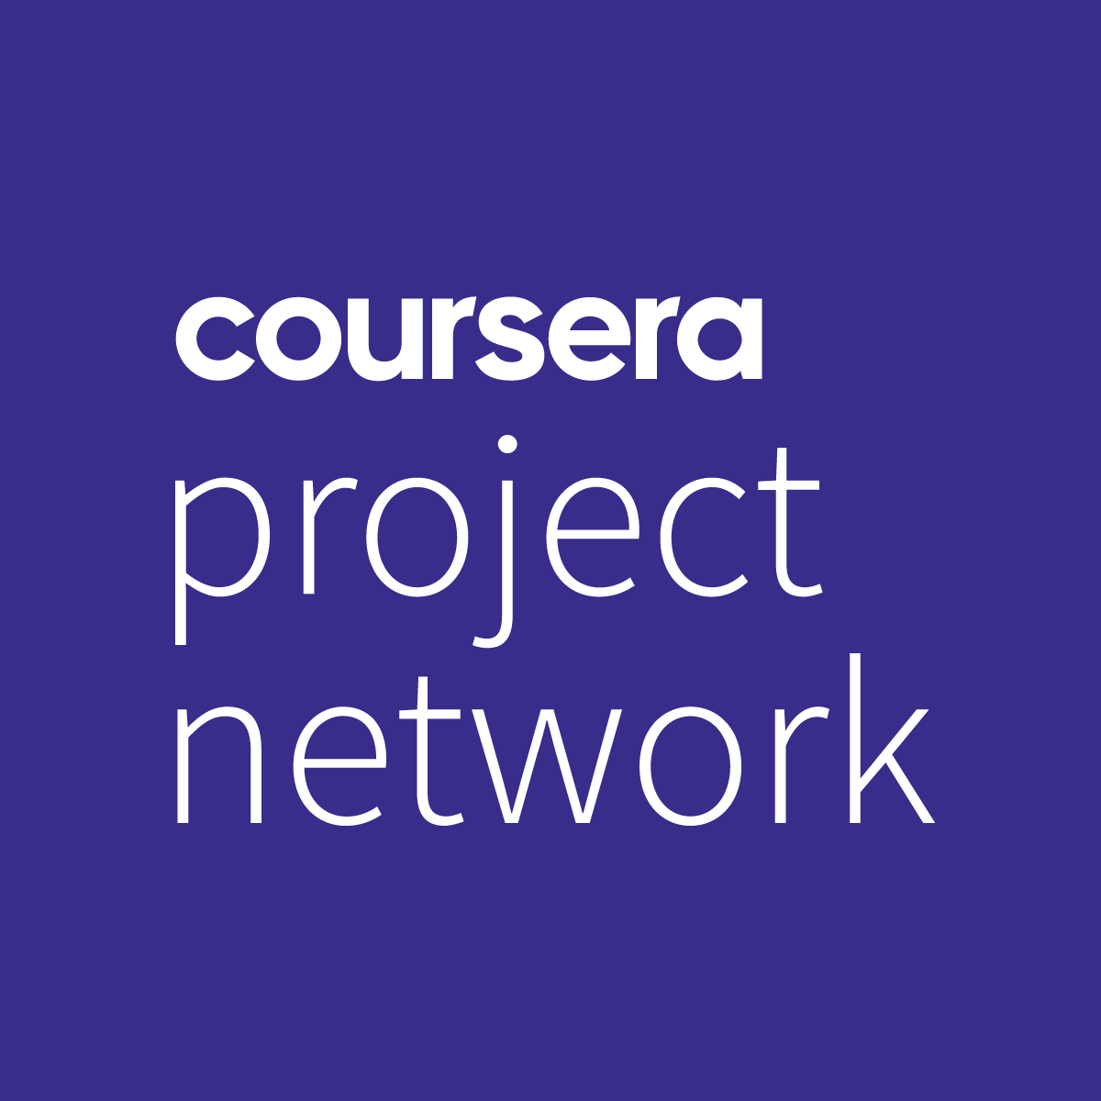

P R O J E C T

C E R T I F I C A T E

Jan 04 , 2023

Niket Kumar

has successfully completed

Build Your First React Website

an online non-credit project authorized by Coursera Project Network and offered through Coursera

E

Harrison Kong

Subject Matter Expert / Instructor Coursera Project Network

Verify at: <https://coursera.org/verify/LFUYACQGAFR7>

Cour se r a ha s confir me d the ide ntity of this individua l a nd the ir

pa r t icipa t ion in the pr oje ct.